VIII-thInternational Scientific Conference
of young scientists, graduates, master and PhD students

“Actual Environmental Problems”, 2018
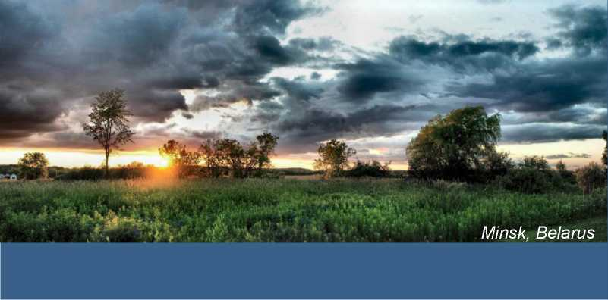
The Conference will be held on November 22-23, 2018 at International Sakharov Environmental Institute of BSU
Address:
23/1 Dolgobrodskaya Street
220070 Minsk
Republic of Belarus
Phone.:+375 17 398 9624
+375 17 398-99-48(only for foreign participants)
Fax: +375 17 398 99 53
Main topics of the Conference
- SOCIAL AND ENVIRONMENTAL, ETHICAL AND PEDAGOGICAL PROBLEMS IN ACCORDANCE WITH A.D.SAKHAROV'S IDEAS
- MEDICAL ECOLOGY
- PROBLEMS OF MODERN ENVIRONMENTAL SAFETY
(BIO-MONITORING, BIO-INDICATION, BIO-REMEDATION, RADIOECOLOGY ANDRADIATIONSAFETY,
ENVIRONMENTAL MONITORING, MANAGMENT AND AUDIT. INFORMATION SYSTEMS AND TECHNOLOGIES IN ECOLOGY)
- CLIMATE CHANGE AND
SUSTAINABLEDEVELOPMENT.
RENEWABLE ENERGY SOURCES AND ENERGY CONSERVATION (Raundtable)

Forms of participation
- Oral presentation at sectional session
- Poster paper
- Distant participation

Presentation of abstracts
To participate in the conference you need to register on the website www.iseu.bsu.by and together with the registration form send the abstracts.
Rules of Abstract Submissionsee on the website http://rfc.iseu.by/.
Paper version of abstracts must be signed by the author and the scientific adviser and transferred to the research sector, room215 (only for participants from ISEI BSU).
Papers are not amended. The author carries out the responsibilities for the scientific content and statement of the paper.
Contents of the abstract should correspond to one of the Conference topics.Abstracts will be reviewed by the Program Committee, which makes the decision about report admission.Papers not meeting the requirements, falling out of the Conference themes or sent after the deadline will not be considered for the selection procedure.
Conference abstracts will be published before the Conference.
E-mail: res_sector@iseu.by,
URL: http://www.iseu.bsu.by

Deadline:
September28, 2018

ENGLISH
WORKING
LANGUAGE:

Rules of Abstract Submission (see more http://rfc.iseu.by)

HEADING SHOULD BE TYPED IN THE MIDDLE, CAPITAL, TIMES NEW ROMAN BOLD ITALIC, AT 12 POINTS, HEADING LINES SHOULD NOT END WITH PREPOSITIONS

Initials of the Name and Surname (for example A. Petrov) (Times New Roman, bold italic, at 12 points)

Full name of the organization (for example, Belarusian State University, ISEI BSU) (Times New Roman italics at 10 points),
City (for example, Minsk), Country (for example, Republic of Belarus)
E-mail:

The annotation should contain no more than 6 lines. The font is Times New Roman, straight, at 10 pt.

Keywords: Please provide no more than 2 lines of key words printed straight.

Contents of abstracts is no more than 1 page А4 with the margins: top and right 2cm, bottom and left 2,5cm. Type: Times New Roman, 10; line spacing: single-space the text.

Requirements for poster
papers drawing up
The conference program will be posted on the Institute website http://rfc.iseu.by/programma/till the 12th of November, 2018.
Supported by:
- INTERNATIONAL SAKHAROV ENVIRONMENTAL INSTITUTE OF BELARUS IAN STATE UNIVERSITY
- BELARUS IAN STATE UNIVERSITY
- MINISTRY OF EDUCATION OF THE REPUBLIC OF BELARUS
- MINISTRY OF NATURAL RESOURCES AND ENVIRONMENTAL PROTECTION
- PUBLIC COUNCIL OF BASIC ORGANIZATION FOR ECOLOGICAL EDUCATION OF CIS MEMBER-STATES
Poster paper should be printed on A1 paper sheet. The order of text layout is the same as in the above mentioned example of abstracts drawing up.
The type is Times New Roman; not less than 28; single-space the text; justified alignment (for body text). Graphic and illustrative material must be maximally presented on the stands.
Papers not meeting the requirements, falling out of the Conference themes or sent after the deadline will not be considered for the selection procedure.

